Assignment no.7
Tree
Course Name : Data Structures-I
Course Code : CS2301
Div : SEDA-B
Student Name : Yashraj Dinesh Hande
Roll Number : 18
Date of Submission : 25/11/2025

Tree
A Tree is a non-linear hierarchical data structure that consists of nodes connected by edges.
It is used to represent data that has a natural hierarchy, such as organizational charts, file systems, or family trees.
The topmost node is called the root, and each node can have child nodes.
A node without any children is called a leaf node.

🔹 Basic Terminology
- Root: The first (topmost) node of the tree.
- Parent and Child: Nodes directly connected by an edge.
- Siblings: Nodes having the same parent.
- Leaf Node: Node with no children.
- Degree: Number of children of a node.
- Height of Tree: Maximum level (depth) of the tree.

🔹 Types of Trees
- General Tree: Each node can have any number of children.
- Binary Tree: Each node has at most two children (left and right).
- Binary Search Tree (BST): A binary tree where the left child < parent < right child.
- AVL Tree: A self-balancing binary search tree.
- Expression Tree: Used to represent arithmetic expressions.

🔹 Tree Traversal Methods
- Inorder (Left → Root → Right)
- Preorder (Root → Left → Right)
- Postorder (Left → Right → Root)
- Level Order (Breadth-First Traversal)

🔹 Applications of Trees
- Hierarchical data representation (files, directories, XML/HTML).
- Binary Search Trees (BST) for fast searching and sorting.
- Expression parsing in compilers.
- Heaps in priority queue implementations.
- Decision-making algorithms and AI.

Problem 1: Write a program to perform Binary Search Tree (BST) operations (Create, Insert, Delete,Levelwise display )
CODE:
#include <iostream>
using namespace std;

#define MAX 100

int bst[MAX];

// Initialize BST
void createBST() {
for (int i = 0; i < MAX; i++)
bst[i] = -1; // -1 means empty
}

// Insert into BST
void insert(int value) {
int i = 1;

while (i < MAX) {
if (bst[i] == -1) {
bst[i] = value;
return;
}
else if (value < bst[i])
i = i * 2; // Move left
else
i = i * 2 + 1; // Move right
}

cout << "Tree overflow! Cannot insert.\n";
}

// Find minimum value index in subtree
int findMinIndex(int index) {
while (index * 2 < MAX && bst[index * 2] != -1)
index = index * 2;
return index;
}

// Delete node
int deleteNode(int index, int value) {
if (index >= MAX || bst[index] == -1)
return -1;

// Traverse left or right
if (value < bst[index])
deleteNode(index * 2, value);

else if (value > bst[index])
deleteNode(index * 2 + 1, value);

else {
// Case 1: No children
if (bst[index * 2] == -1 && bst[index * 2 + 1] == -1) {
bst[index] = -1;
}

// Case 2: One child
else if (bst[index * 2] == -1) {
bst[index] = bst[index * 2 + 1];
deleteNode(index * 2 + 1, bst[index]);
}
else if (bst[index * 2 + 1] == -1) {
bst[index] = bst[index * 2];
deleteNode(index * 2, bst[index]);
}

// Case 3: Two children
else {
int minIndex = findMinIndex(index * 2 + 1);
bst[index] = bst[minIndex];
deleteNode(minIndex, bst[minIndex]);
}
}
return 1;
}

// Display Level-wise
void levelOrder() {
cout << "\nLevel-wise BST:\n";
for (int i = 1; i < MAX; i++) {
if (bst[i] != -1)
cout << "Index " << i << ": " << bst[i] << "\n";
}
}

int main() {
createBST();

int choice, value;

while (true) {
cout << "\n--- BST ARRAY MENU ---\n";
cout << "1. Insert\n";
cout << "2. Delete\n";
cout << "3. Level-wise Display\n";
cout << "4. Exit\n";
cout << "Enter choice: ";
cin >> choice;

switch (choice) {
case 1:
cout << "Enter value to insert: ";
cin >> value;
insert(value);
break;

case 2:
cout << "Enter value to delete: ";
cin >> value;
deleteNode(1, value);
break;

case 3:
levelOrder();
break;

case 4:
return 0;

default:
cout << "Invalid choice.\n";
}
}

return 0;
}

OUTPUT:
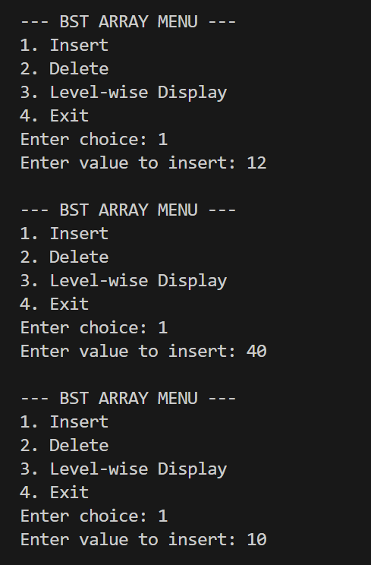
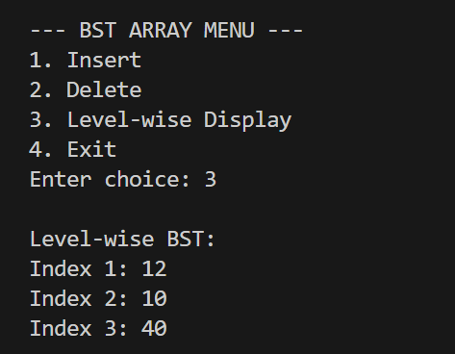

Problem 2: Write a program to perform Binary Search Tree (BST) operations (Count the total number of nodes, Compute the height of the BST, Mirror Image ).

CODE:
#include <iostream>
using namespace std;

// Node structure
struct Node {
int data;
Node* left;
Node* right;
};

// Function to create a new node
Node* createNode(int value) {
Node* newNode = new Node();
newNode->data = value;
newNode->left = newNode->right = NULL;
return newNode;
}

// Insert a node in BST
Node* insert(Node* root, int value) {
if (root == NULL) {
root = createNode(value);
return root;
}
if (value < root->data)
root->left = insert(root->left, value);
else
root->right = insert(root->right, value);

return root;
}

// Count total number of nodes
int countNodes(Node* root) {
if (root == NULL)
return 0;
return 1 + countNodes(root->left) + countNodes(root->right);
}

// Compute height of BST
int height(Node* root) {
if (root == NULL)
return 0;

int leftHeight = height(root->left);
int rightHeight = height(root->right);

return 1 + max(leftHeight, rightHeight);
}

// Mirror image of BST
Node* mirror(Node* root) {
if (root == NULL)
return NULL;

// Swap left and right subtrees
Node* temp = root->left;
root->left = root->right;
root->right = temp;

// Recursively mirror subtrees
mirror(root->left);
mirror(root->right);

return root;
}

// Inorder Traversal
void inorder(Node* root) {
if (root != NULL) {
inorder(root->left);
cout << root->data << " ";
inorder(root->right);
}
}

int main() {
Node* root = NULL;
int choice, value;

while (true) {
cout << "\n--- BST Operations ---\n";
cout << "1. Insert Node\n";
cout << "2. Count Total Nodes\n";
cout << "3. Compute Height of BST\n";
cout << "4. Display Mirror Image (Inorder)\n";
cout << "5. Display Inorder Traversal\n";
cout << "6. Exit\n";
cout << "Enter your choice: ";
cin >> choice;

switch (choice) {
case 1:
cout << "Enter value to insert: ";
cin >> value;
root = insert(root, value);
break;

case 2:
cout << "Total Nodes = " << countNodes(root) << endl;
break;

case 3:
cout << "Height of BST = " << height(root) << endl;
break;

case 4:
mirror(root);
cout << "Mirror Image (Inorder): ";
inorder(root);
cout << endl;
break;

case 5:
cout << "Inorder Traversal: ";
inorder(root);
cout << endl;
break;

case 6:
return 0;

default:
cout << "Invalid Choice!\n";
}
}

OUTPUT:
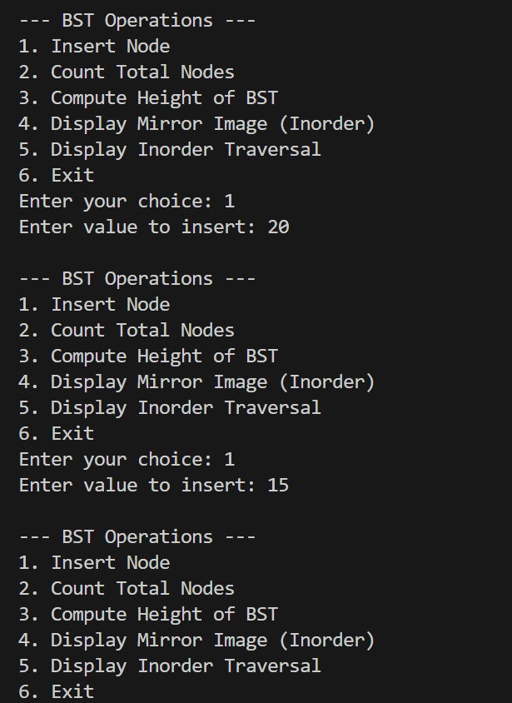
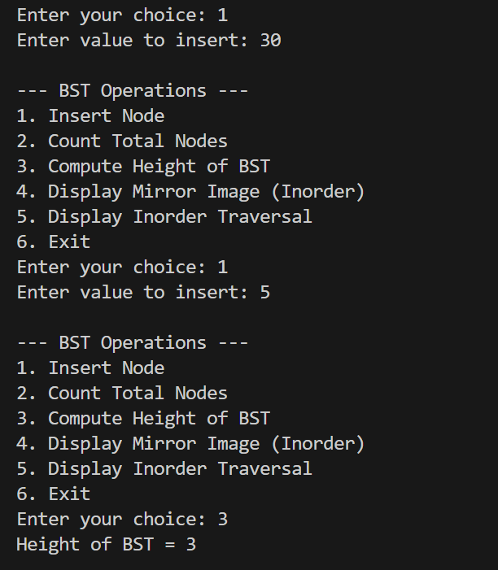

Problem 3 : Write a Program to create a Binary Tree Search and Find Minimum/Maximum in BST
CODE:
#include <iostream>
using namespace std;

// Node structure
struct Node {
int data;
Node* left;
Node* right;
};

// Create a new node
Node* createNode(int value) {
Node* temp = new Node();
temp->data = value;
temp->left = NULL;
temp->right = NULL;
return temp;
}

// Insert into BST
Node* insert(Node* root, int value) {
if (root == NULL) {
return createNode(value);
}

if (value < root->data)
root->left = insert(root->left, value);
else
root->right = insert(root->right, value);

return root;
}

// Find Minimum
int findMin(Node* root) {
if (root == NULL) {
cout << "Tree is empty.\n";
return -1;
}

while (root->left != NULL) {
root = root->left;
}

return root->data;
}

// Find Maximum
int findMax(Node* root) {
if (root == NULL) {
cout << "Tree is empty.\n";
return -1;
}

while (root->right != NULL) {
root = root->right;
}

return root->data;
}
// Level-wise display (simple inorder)
void inorder(Node* root) {
if (root != NULL) {
inorder(root->left);
cout << root->data << " ";
inorder(root->right);
}
}
int main() {
Node* root = NULL;
int choice, value;
while (true) {
cout << "\n---- BST MENU ----\n";
cout << "1. Insert\n";
cout << "2. Find Minimum\n";
cout << "3. Find Maximum\n";
cout << "4. Display (Inorder)\n";
cout << "5. Exit\n";
cout << "Enter your choice: ";
cin >> choice;
switch (choice) {
case 1:
cout << "Enter value to insert: ";
cin >> value;
root = insert(root, value);
break;
case 2:
cout << "Minimum value: " << findMin(root) << endl;
break;
case 3:
cout << "Maximum value: " << findMax(root) << endl;
break;
case 4:
cout << "BST (Inorder): ";
inorder(root);
cout << endl;
break;

case 5:
return 0;
default:
cout << "Invalid choice.\n";
}
}
}

OUTPUT:
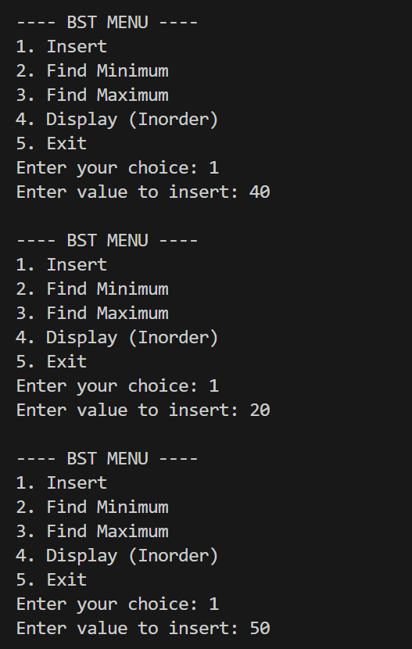
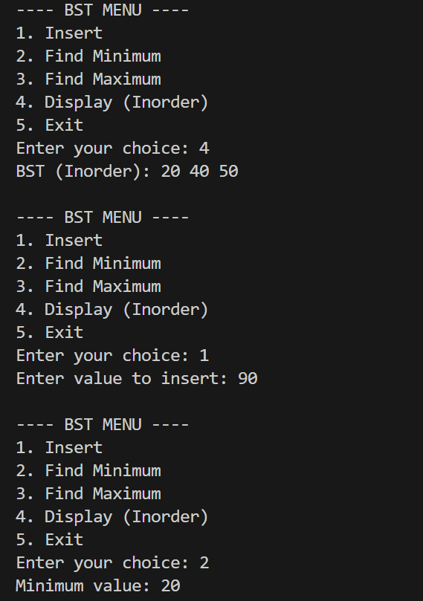

Problem 4 : Write a Program to create a Binary Tree and perform following Nonrecursive operations on it. a. Inorder Traversal b. Preorder Traversal c. Display Number of Leaf Nodes d. Mirror Image

CODE:
#include <iostream>
#include <stack>
using namespace std;

struct Node {
int data;
Node *left, *right;
};

// Create new node
Node* createNode(int value) {
Node* temp = new Node();
temp->data = value;
temp->left = temp->right = NULL;
return temp;
}

// Insert node (simple binary tree insertion)
Node* insert(Node* root, int value) {
if (root == NULL)
return createNode(value);

queue<Node*> q;
q.push(root);

while (!q.empty()) {
Node* temp = q.front();
q.pop();

if (temp->left == NULL) {
temp->left = createNode(value);
break;
} else q.push(temp->left);

if (temp->right == NULL) {
temp->right = createNode(value);
break;
} else q.push(temp->right);
}
return root;
}

// a) NON-RECURSIVE INORDER TRAVERSAL
void inorderNR(Node* root) {
stack<Node*> st;
Node* curr = root;

while (curr != NULL || !st.empty()) {
while (curr != NULL) {
st.push(curr);
curr = curr->left;
}

curr = st.pop();
cout << curr->data << " ";
curr = curr->right;
}
}

// b) NON-RECURSIVE PREORDER TRAVERSAL
void preorderNR(Node* root) {
if (root == NULL) return;

stack<Node*> st;
st.push(root);

while (!st.empty()) {
Node* temp = st.top();
st.pop();

cout << temp->data << " ";

if (temp->right) st.push(temp->right);
if (temp->left) st.push(temp->left);
}
}

// c) COUNT LEAF NODES (non-recursive)
int countLeaf(Node* root) {
if (root == NULL) return 0;

int count = 0;
stack<Node*> st;
st.push(root);

while (!st.empty()) {
Node* temp = st.top();
st.pop();

if (temp->left == NULL && temp->right == NULL)
count++;

if (temp->right) st.push(temp->right);
if (temp->left) st.push(temp->left);
}
return count;
}

// d) MIRROR IMAGE (non-recursive)
void mirrorNR(Node* root) {
if (root == NULL) return;

stack<Node*> st;
st.push(root);

while (!st.empty()) {
Node* temp = st.top();
st.pop();

// Swap children
Node* t = temp->left;
temp->left = temp->right;
temp->right = t;

if (temp->left) st.push(temp->left);
if (temp->right) st.push(temp->right);
}
}

int main() {
Node* root = NULL;
int n, val;

cout << "Enter number of nodes: ";
cin >> n;

cout << "Enter node values: ";
for (int i = 0; i < n; i++) {
cin >> val;
root = insert(root, val);
}

cout << "\nNon-Recursive Inorder: ";
inorderNR(root);

cout << "\nNon-Recursive Preorder: ";
preorderNR(root);

cout << "\nNumber of Leaf Nodes: " << countLeaf(root);

mirrorNR(root);
cout << "\nMirror Image Inorder: ";
inorderNR(root);

return 0;
}

OUTPUT:

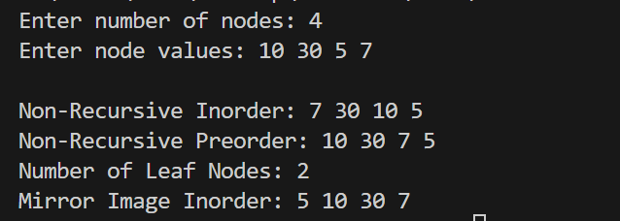

Problem 5 : Write a Program to create a Binary Tree and perform the following Recursive operations on it. a. Inorder Traversal b. Preorder Traversal c. Display Number of Leaf Nodes d. Mirror Image.

CODE:
#include <iostream>
#include <queue>
using namespace std;

struct Node {
int data;
Node* left;
Node* right;
};

// Create a new node
Node* createNode(int value) {
Node* temp = new Node();
temp->data = value;
temp->left = temp->right = NULL;
return temp;
}

// Insert node (level order insertion to create simple binary tree)
Node* insert(Node* root, int value) {
if (root == NULL)
return createNode(value);

queue<Node*> q;
q.push(root);

while (!q.empty()) {
Node* temp = q.front();
q.pop();

if (!temp->left) {
temp->left = createNode(value);
break;
} else q.push(temp->left);

if (!temp->right) {
temp->right = createNode(value);
break;
} else q.push(temp->right);
}
return root;
}

//////////////////////////
// RECURSIVE FUNCTIONS
//////////////////////////

// a) Inorder Traversal (L, Root, R)
void inorder(Node* root) {
if (root == NULL)
return;
inorder(root->left);
cout << root->data << " ";
inorder(root->right);
}

// b) Preorder Traversal (Root, L, R)
void preorder(Node* root) {
if (root == NULL)
return;
cout << root->data << " ";
preorder(root->left);
preorder(root->right);
}

// c) Count Leaf Nodes
int countLeaf(Node* root) {
if (root == NULL)
return 0;

if (root->left == NULL && root->right == NULL)
return 1;

return countLeaf(root->left) + countLeaf(root->right);
}

// d) Mirror Image (swap children recursively)
void mirror(Node* root) {
if (root == NULL)
return;

// Swap left & right
Node* temp = root->left;
root->left = root->right;
root->right = temp;

mirror(root->left);
mirror(root->right);
}

//////////////////////////

int main() {
Node* root = NULL;
int n, value;

cout << "Enter number of nodes: ";
cin >> n;

cout << "Enter node values: ";
for (int i = 0; i < n; i++) {
cin >> value;
root = insert(root, value);
}

cout << "\nRecursive Inorder Traversal: ";
inorder(root);

cout << "\nRecursive Preorder Traversal: ";
preorder(root);

cout << "\nNumber of Leaf Nodes: " << countLeaf(root);

mirror(root);
cout << "\n\nTree After Mirror (Inorder): ";
inorder(root);

cout << endl;
return 0;
}

OUTPUT:

